**Web Programming Quiz**

Muhammad Ribhi Ramadan – 2702341303

**EduFun Web Application**

**Home Page:**

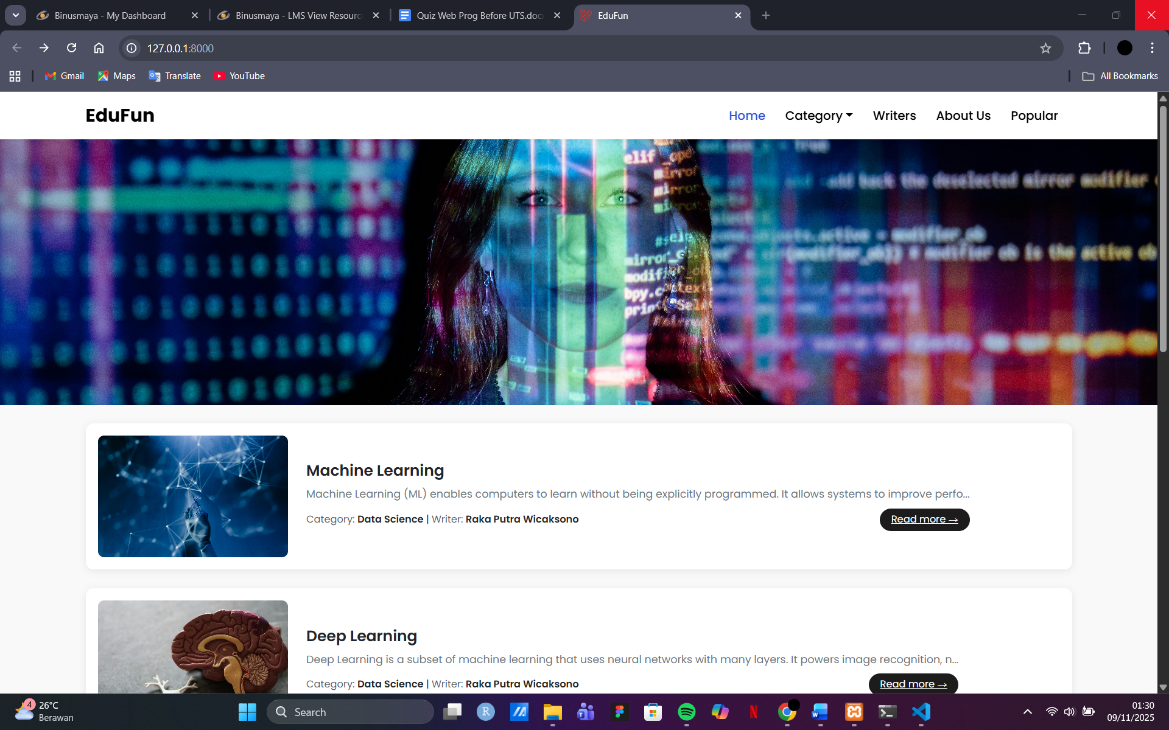

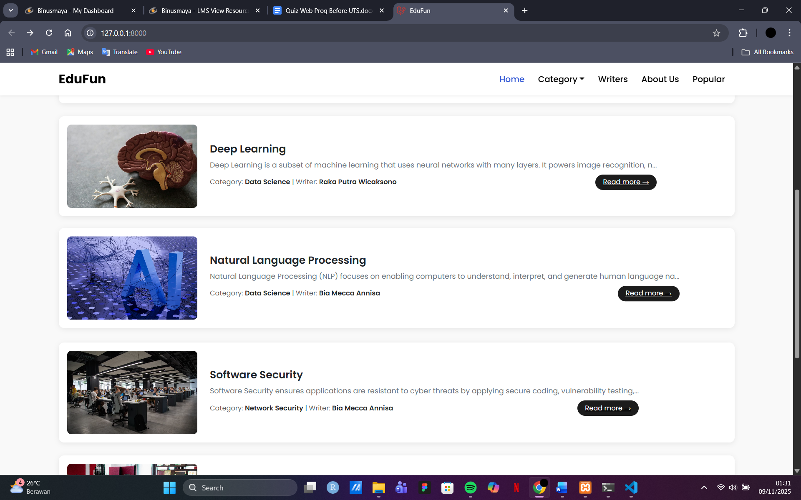

**Footer + Select Category:**

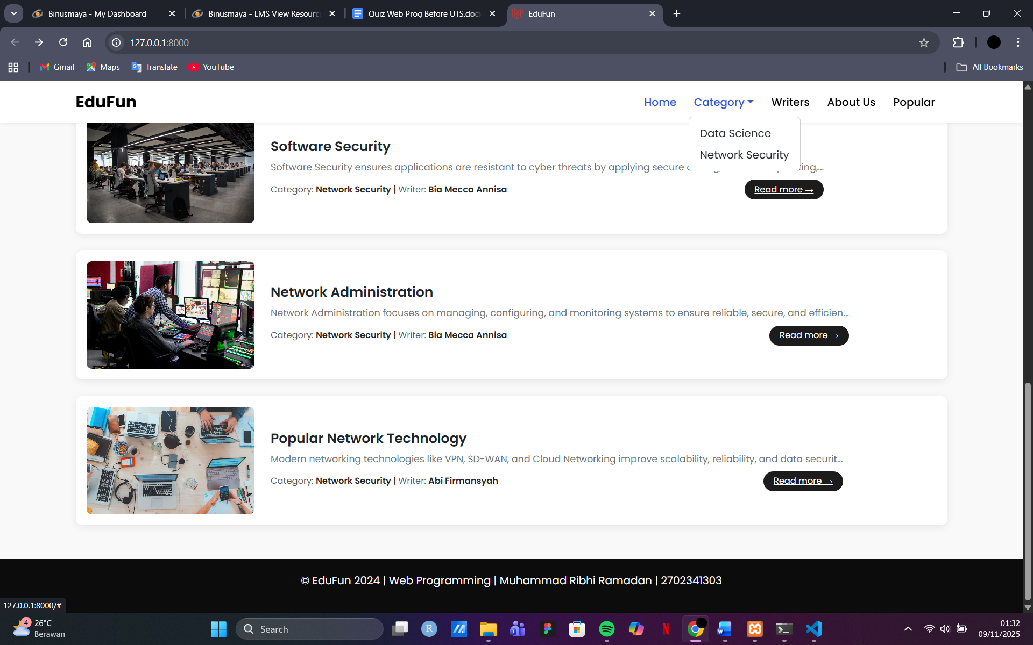

**Category (Data Science):**

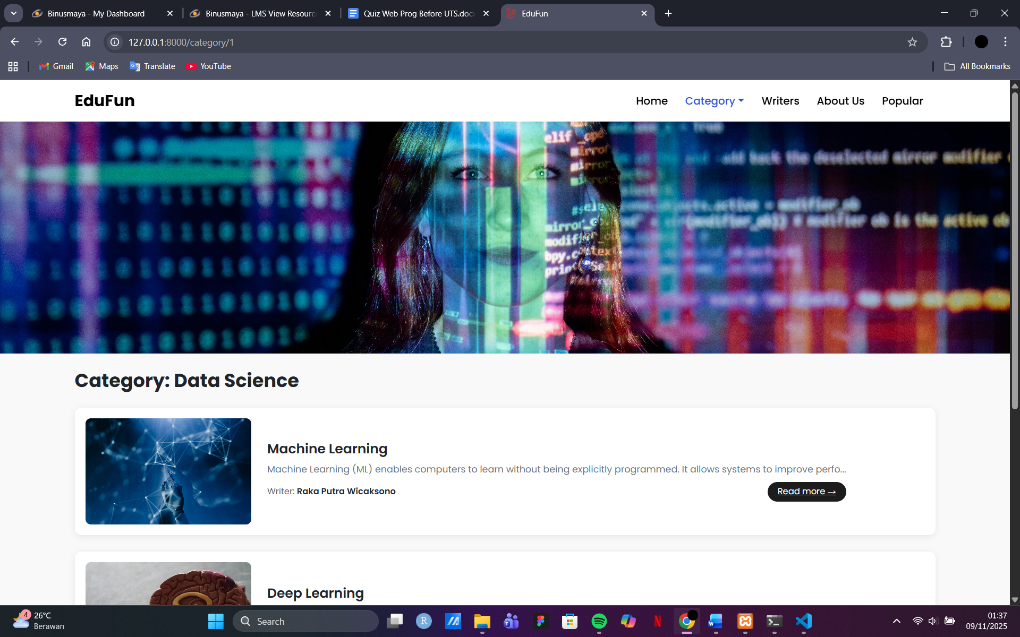

**Read More (Machine Learning, from Data Science):**

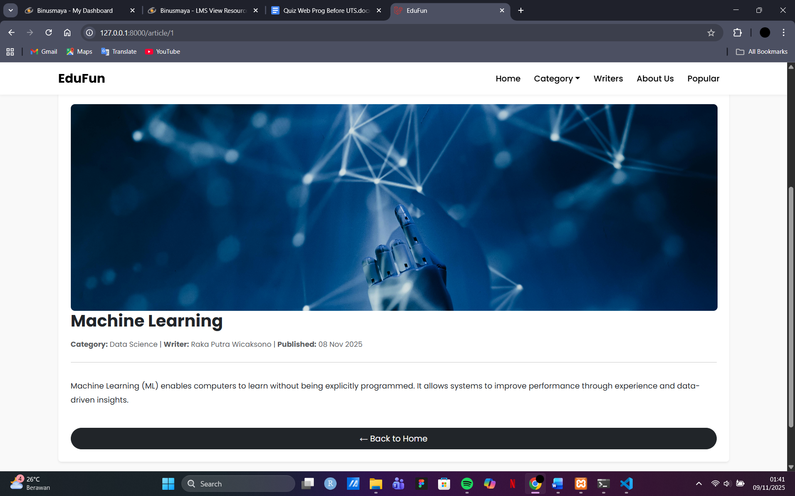

**Category (Network Security):**

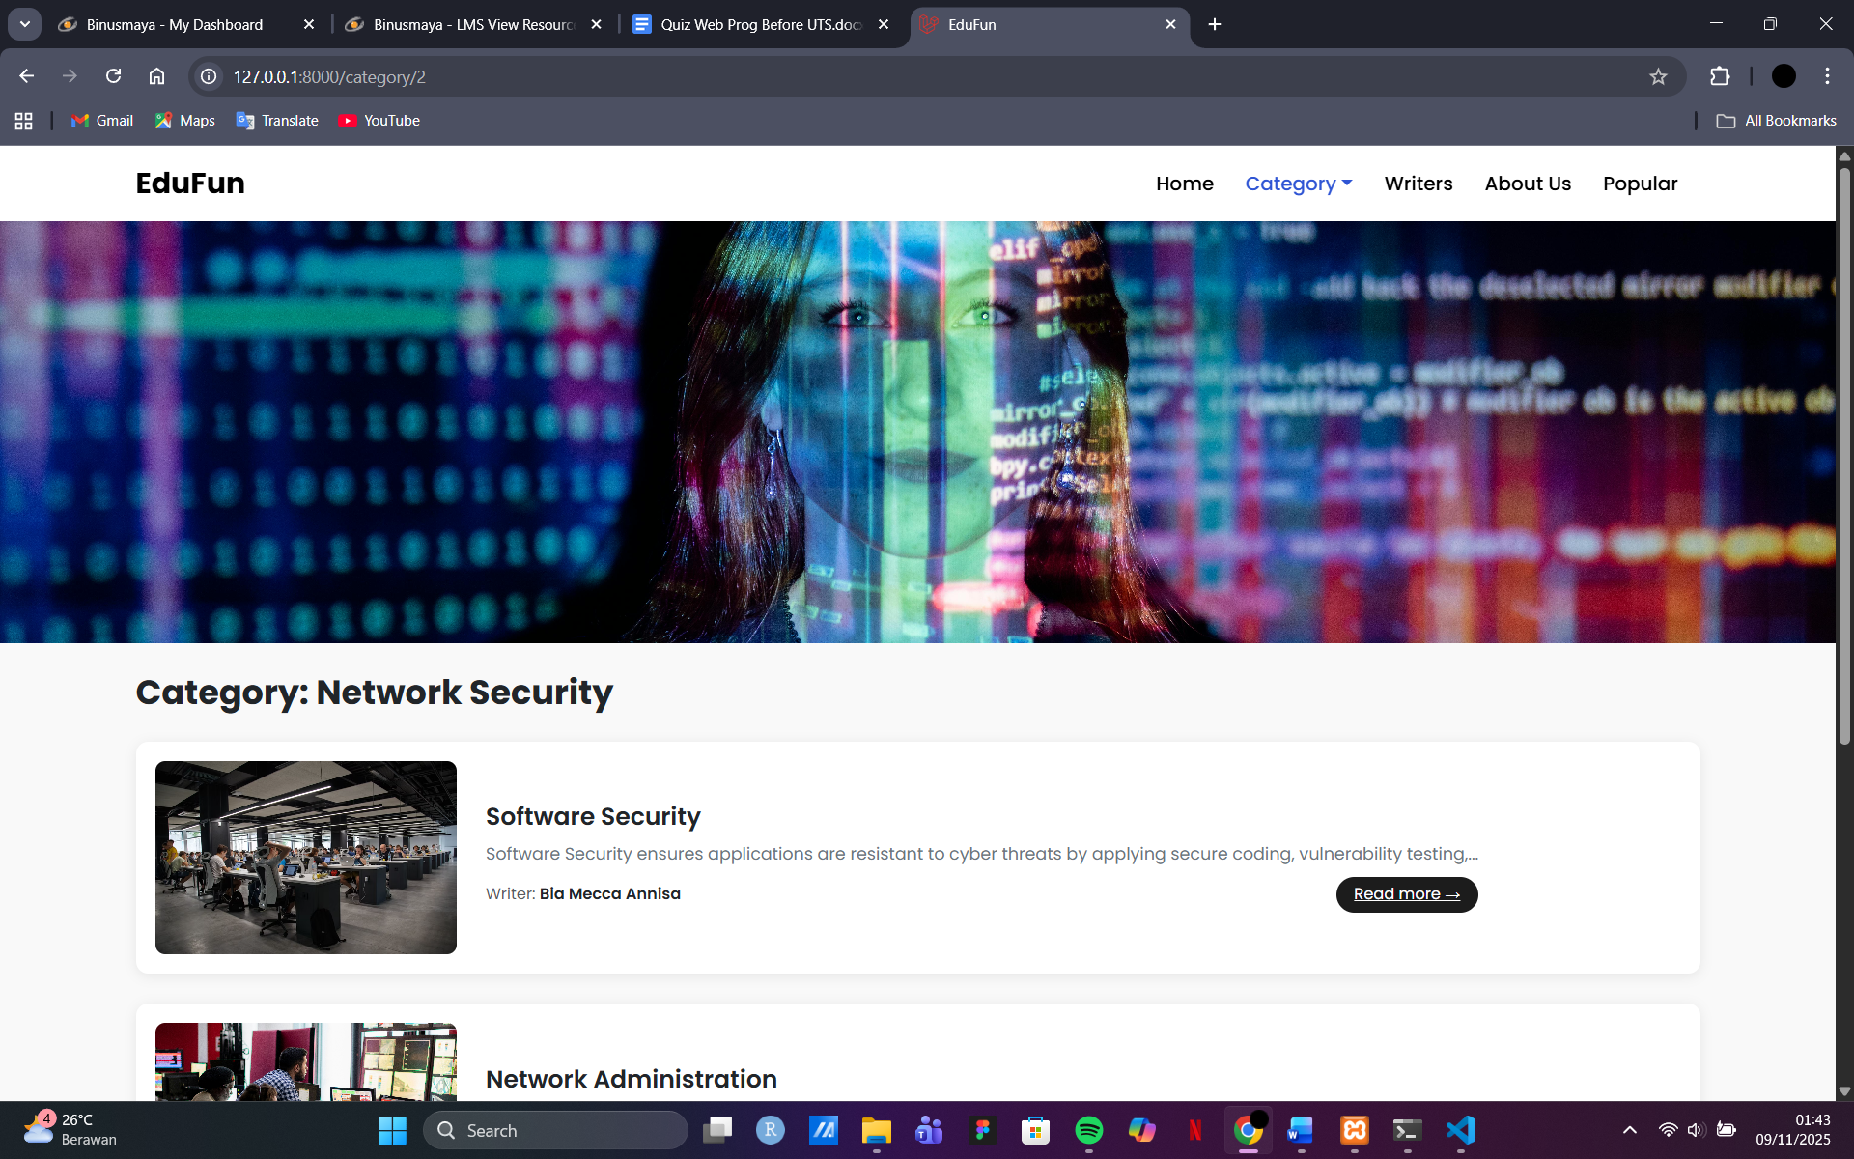

**Read More (Software Security, from Network Security):**

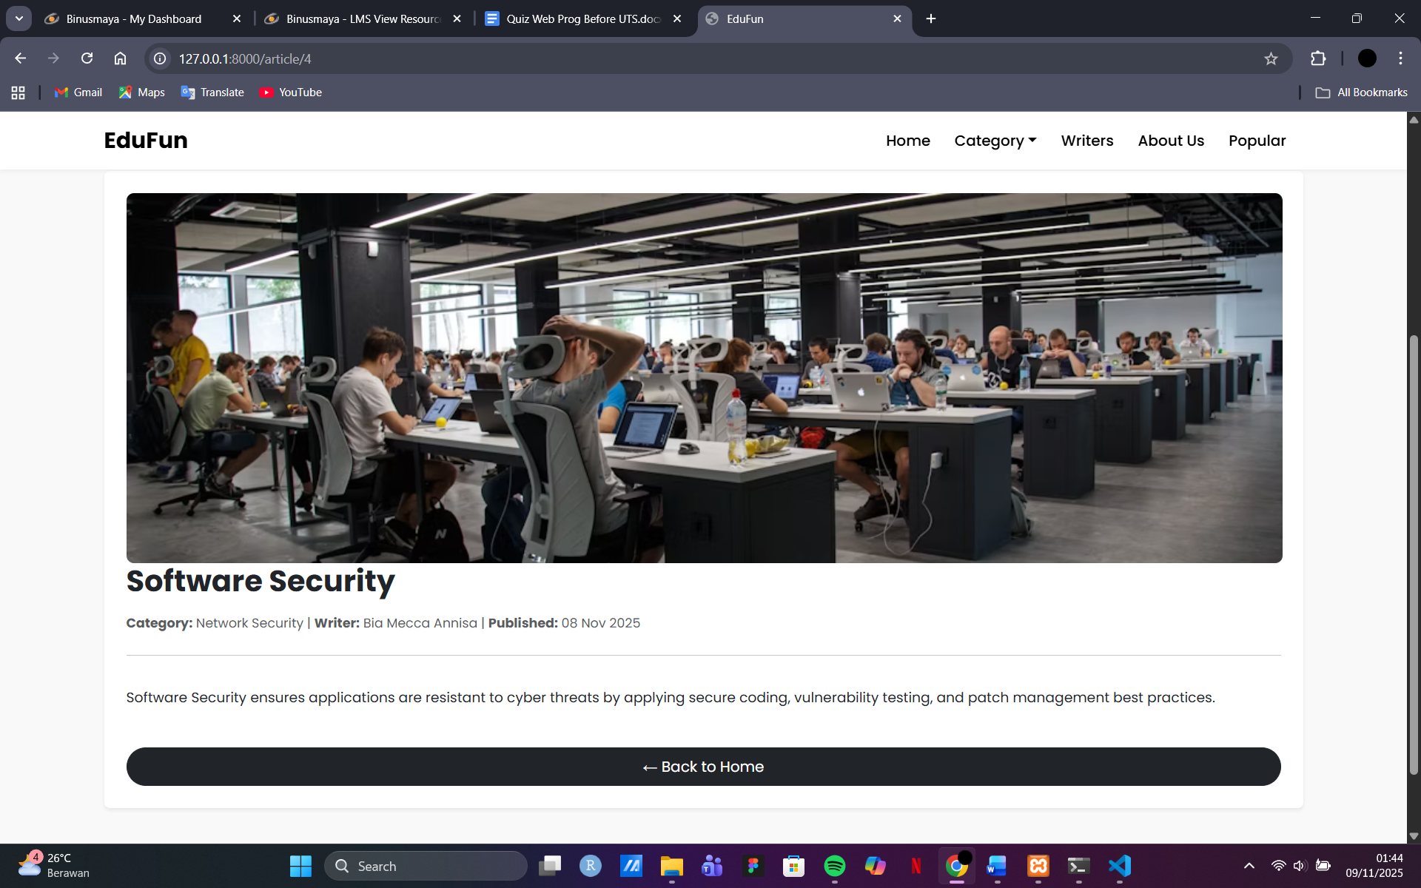

**Writers:**

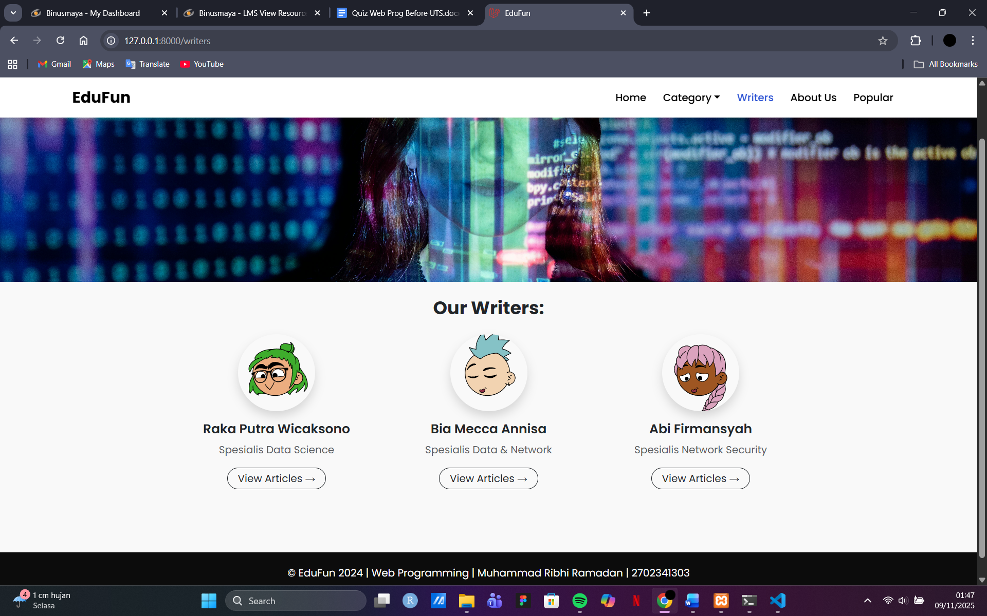

**View Articles (Writers):**

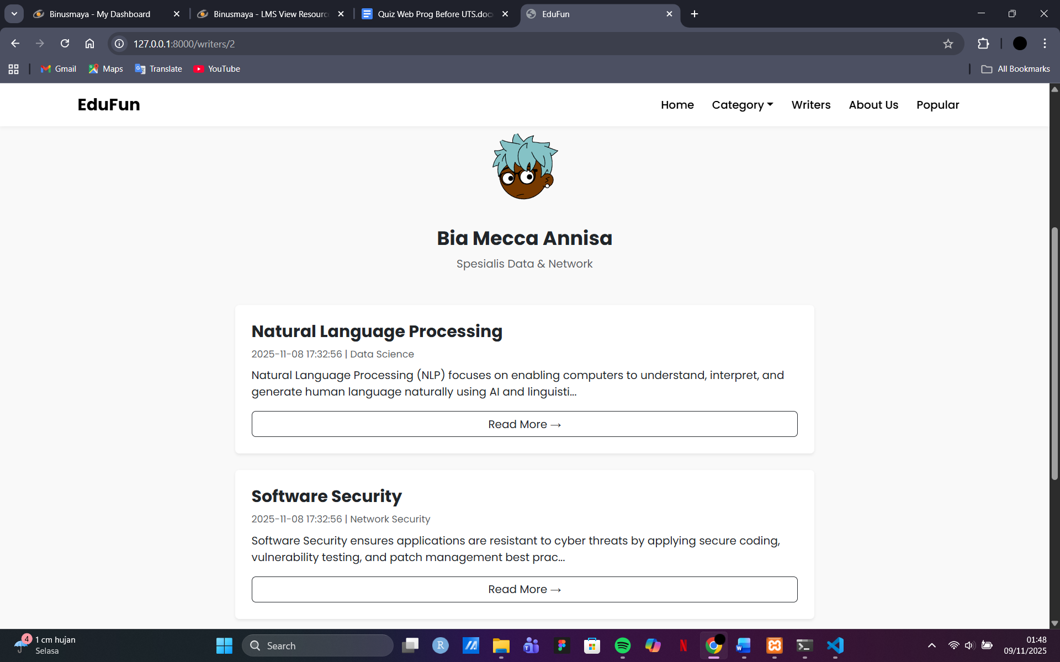

**About Us:**

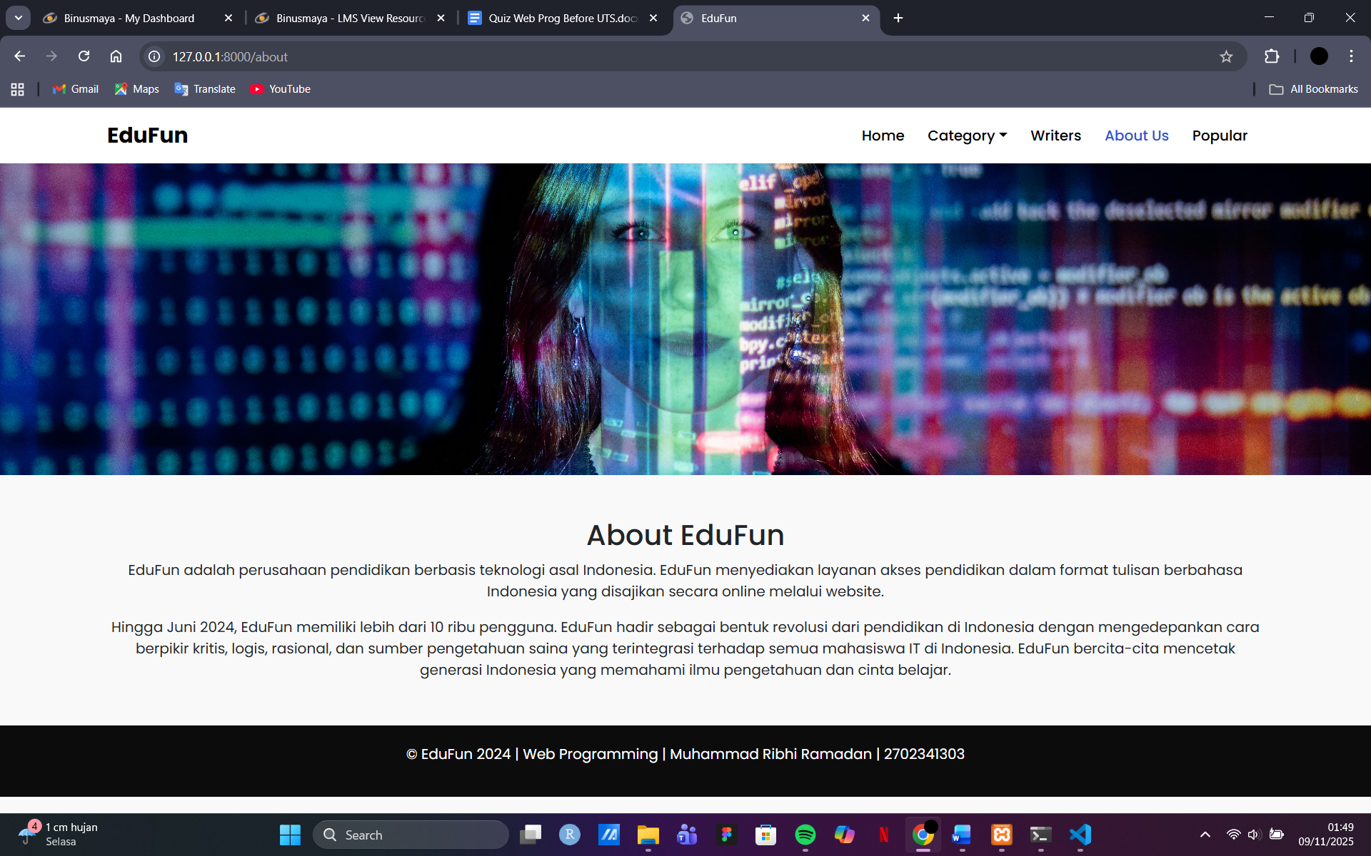

**Popular (Page 1 and 2):**

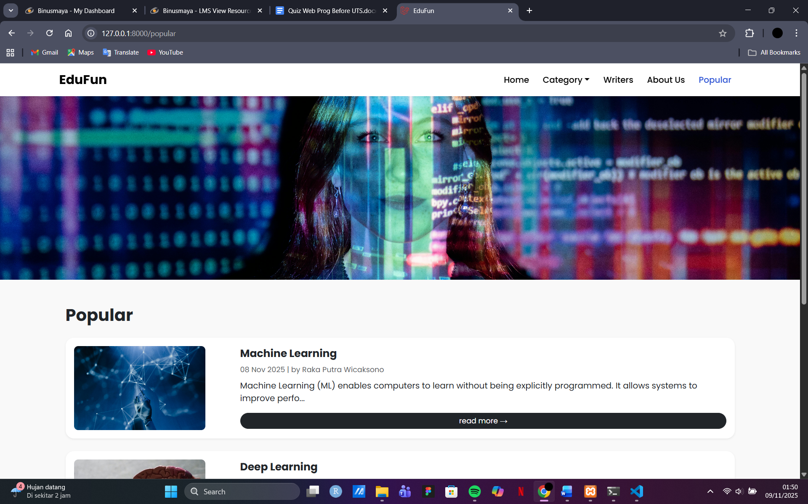

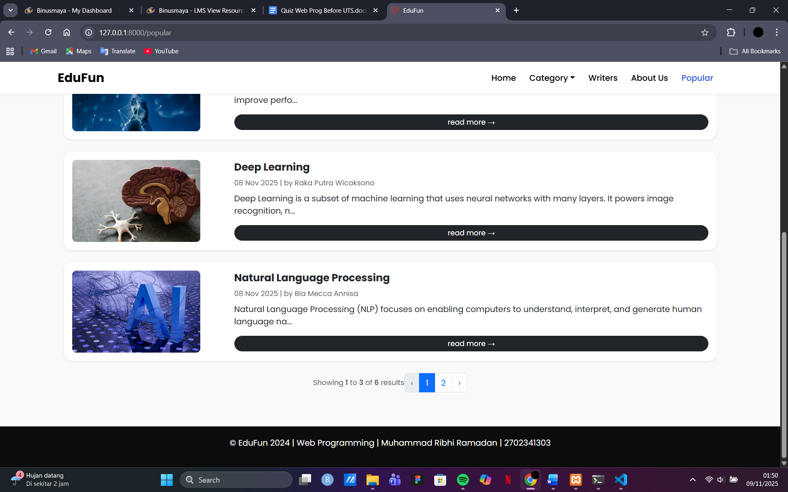

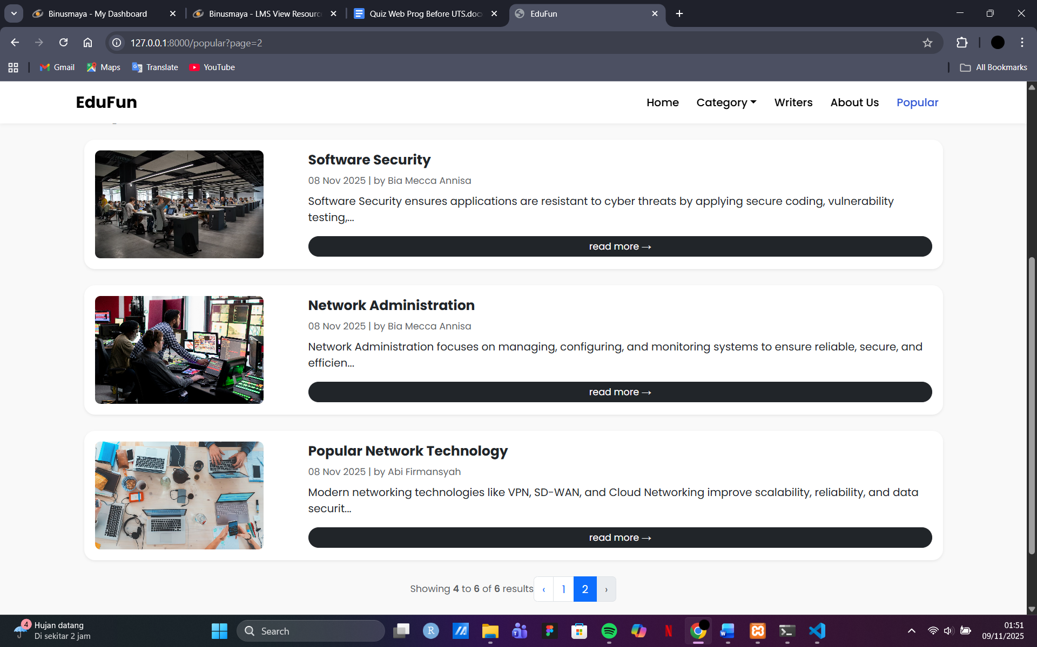

**EduFun Demo Video Link:**

[**https://drive.google.com/file/d/1lGcQ-n4z4SyR50Z3wcF_rzcOrhc0V3_W/view?usp=sharing**](https://drive.google.com/file/d/1lGcQ-n4z4SyR50Z3wcF_rzcOrhc0V3_W/view?usp=sharing)

**GitHub Link:**

[**https://github.com/MuhammadRibhiRamadan/EduFun**](https://github.com/MuhammadRibhiRamadan/EduFun)

**Contact:**

**WhatsApp:** 0851-7964-7008

**ID LINE:** mribhir

**Penjelasan *detail* mengenai *routing, controller, model, view and blade, dll*:**

1. **Ringkasan singkat project**

**EduFun** adalah aplikasi web edukasi sederhana berbasis **Laravel**. Fitur utama:

* Halaman Home (daftar artikel terbaru)
* Category (Data Science & Network Security — sesuai NIM ganjil)
* Detail Article (halaman read more)
* Writers (daftar penulis + halaman detail penulis)
* About Us
* (Opsional) Popular page dengan pagination

Teknologi: **Laravel**, **Blade**, **Bootstrap**, **SQLite** (atau MySQL), migrasi & seeder.

1. **Routing**

Routing adalah pengaturan URL ke fungsi controller. File utama: routes/web.php.

Contoh route di EduFun:

|  |
| --- |
| use App\Http\Controllers\EduFunController;  Route::get('/', [EduFunController::class, 'home'])->name('home');  Route::get('/category/{id}', [EduFunController::class, 'category'])->name('category');  Route::get('/writers', [EduFunController::class, 'writers'])->name('writers');  Route::get('/writers/{id}', [EduFunController::class, 'showWriter'])->name('writer.show');  Route::get('/about', [EduFunController::class, 'about'])->name('about');  Route::get('/article/{id}', [EduFunController::class, 'show'])->name('article.show');  Route::get('/popular', [EduFunController::class, 'popular'])->name('popular'); |

**Penjelasan:**

* Route::get menerima URL dan menghubungkannya ke method controller.
* name('...') memberi nama route agar mudah dipanggil di Blade (mis. route('home')).

1. **Controller**

Controller memproses request, ambil data dari model, lalu mengembalikan view.

File contoh: app/Http/Controllers/EduFunController.php

Contoh:

|  |
| --- |
| class EduFunController extends Controller  {      // Home Page      public function home()      {          $articles = Article::with('category', 'writer')->latest()->get();          return view('home', compact('articles'));      }      // Category Page      public function category($id)      {          $category = Category::findOrFail($id);          $articles = Article::where('category_id', $id)->with('writer')->get();          return view('category', compact('category', 'articles'));      }      // Writers Page      public function writers()      {          $writers = \App\Models\Writer::all();          return view('writers', compact('writers'));      }      public function showWriter($id)      {          $writer = \App\Models\Writer::findOrFail($id);          $articles = \App\Models\Article::where('writer_id', $id)->with('category')->get();          return view('writer-detail', compact('writer', 'articles'));      }      // About Page      public function about()      {          return view('about');      }      public function show($id)      {          $article = \App\Models\Article::with('category', 'writer')->findOrFail($id);          return view('detail', compact('article'));      }      // Popular Page      public function popular()      {          $articles = \App\Models\Article::orderBy('id', 'asc')->paginate(3);          return view('popular', compact('articles'));      }  } |

1. **Model (Eloquent)**

Model menyatakan tabel database dan relasi.

Contoh app/Models/Article.php:

|  |
| --- |
| namespace App\Models;  use Illuminate\Database\Eloquent\Model;  class Article extends Model  {      protected $casts = [      'published_at' => 'datetime',      ];          //          public function category()      {          return $this->belongsTo(Category::class);      }          public function writer()      {          return $this->belongsTo(Writer::class);      }  } |

Contoh app/Models/Category.php:

|  |
| --- |
| class Category extends Model  {  protected $fillable = ['name'];  public function articles()  {  return $this->hasMany(Article::class);  }  } |

Contoh app/Models/Writer.php:

|  |
| --- |
| class Writer extends Model  {  protected $fillable = ['name','speciality'];  public function articles()  {  return $this->hasMany(Article::class);  }  } |

1. **View & Blade (Frontend)**

Views berada di resources/views. Gunakan Blade templating untuk komponen layout.

Contoh struktur:

|  |
| --- |
| resources/views/  layout.blade.php <-- base layout (head, navbar, footer)  home.blade.php  category.blade.php  detail.blade.php  writers.blade.php  writer-detail.blade.php  popular.blade.php |

Contoh layout.blade.php (sederhana):

|  |
| --- |
| <!doctype html>  <html>  <head>  <meta charset="utf-8">  <title>EduFun</title>  <link href="...bootstrap..." rel="stylesheet">  </head>  <body>  @include('partials.navbar')  <div class="container mt-4">  @yield('content')  </div>  @include('partials.footer')  </body>  </html> |

Contoh penggunaan di detail.blade.php:

|  |
| --- |
| @extends('layout')  @section('content')  <div class="card shadow-sm p-4">  <img src="{{ $article->image }}" alt="Article Image" style="width:100%; height:400px; object-fit:cover;">  <h2>{{ $article->title }}</h2>  <p><strong>Category:</strong> {{ $article->category->name }} | <strong>Writer:</strong> {{ $article->writer->name }}</p>  <p>{!! nl2br(e($article->content)) !!}</p>  </div>  @endsection |

1. **Migration**

Migration membuat struktur tabel di database.

Contoh migration create_writers_table:

|  |
| --- |
| Schema::create('writers', function (Blueprint $table) {  $table->id();  $table->string('name');  $table->string('speciality')->nullable();  $table->timestamps();  }); |

Cara menjalankan migration:

|  |
| --- |
| php artisan migrate  # atau untuk reset+seed  php artisan migrate:fresh --seed |

1. **Seeder & Faker**

Seeder mengisi data awal untuk development/testing.

Contoh database/seeders/WriterSeeder.php:

|  |
| --- |
| DB::table('writers')->insert([  ['name' => 'Raka Putra Wicaksono', 'speciality' => 'Interactive Multimedia'],  ['name' => 'Bia Mecca Annisa', 'speciality' => 'Data Science'],  ['name' => 'Abi Firmansyah', 'speciality' => 'Network Security'],  ]); |